
American International University-Bangladesh (AIUB)
Department of Computer Science
Faculty of Science &Technology (FST)
Summer 25 26
Section: A
Software Quality Assurance and Testing
Online Job Portal
A Report submitted
By

SN | Student Name | Student ID
1 | MD SHAKIB HOSSEN | 22-49339-3
2 | MST. SUMAIYA SIDDIKA | 23-51348-1
3 | MD. IMDADUL HASAN (AYON) | 22-49959-3

Checked By Industry Personnel (Optional)

Name: Mijanur Rahman Shovon

Designation: Software Quality Assurance Engineer

Company: Brain Station 23

Sign:

Date:

Software Test Plan

for

Online Job Portal
Version 1.0 approved
Prepared by :
- Md. Shakib Hossen
- Mst. Sumaiya Siddika
- Md. Imdadul Hasan (Ayon)

Contents
REVISION HISTORY ....................................................................................................3
1.TEST PLAN IDENTIFIER: CK-MTP-01 ...................................................................4
2.REFERENCES .............................................................................................................4
3.INTRODUCTION ......................................................................................................4-6
4.REQUIREMENT SPECIFICATION .........................................................................6-13
5.FEATURES NOT TO BE TESTED ...........................................................................13-14
6.TESTING APPROCH .................................................................................................14-15
7.TEST CASES/TEST ITEMS ....................................................................................... 1-37
8.ITEM PASS/FAIL CRITERIA ......................................................................................16
9.TEST DELIVERABLES ..............................................................................................16-18
10.STAFFING AND TRAINING NEEDS .....................................................................18-19
11.RESPONSIBILITIES ..................................................................................................19
12.TESTING SCHEDULE ................................................................................................20
13. PLANNING RISKS AND CONTINGENCIES .......................................................21
14. APROVALS.................................................................................................................22

Revision | Date | Updated by | Update Comments
0.1 | 2026.08.28 | Sumaiya, Shakib, Ayon | 1st Draft
0.2 | 2026.08.31 | Sumaiya, Shakib, Ayon | 2nd Draft
0.3 | 2026.09.02 | Sumaiya, Shakib, Ayon | 3rd Draft
0.4 | 2026.09.05 | Sumaiya, Shakib, Ayon | 4th Draft
0.5 | 2026.09.07 | Sumaiya, Shakib, Ayon | 5th Draft
0.6 | 2026.09.12 | Sumaiya, Shakib, Ayon | 6th Draft
Revision History

TEST PLAN IDENTIFIER: OJP-MTP-01

REFERENCES
Online Job Portal is a web-based recruitment platform designed to connect Job Seekers with Employers. The system provides role-based access for three types of users: Job Seekers, Employers, and Administrators. It enables job posting, job browsing, application submission, application status management, and user administration.
The platform is developed using a custom Native PHP MVC (Model-View-Controller) framework to ensure a structured, maintainable, and secure software architecture. Session management and cookie-based “Remember Me” functionality are integrated for smooth user experience.
The system consists of three primary users:
- Job Seeker – Can register, browse/search jobs, apply for jobs, track application status, and manage personal profile.
- Employer – Can register, post/edit/delete jobs, view applications, update application status, and manage company profile.
- Administrator – Can view system statistics, manage users (edit/delete), and manage all job listings.

Reference Document: This Software Requirement Specification (SRS) document (derived from source code analysis) serves as a reference for the system design, development, and preparation of the test plan for Online Job Portal.

INTRODUCTION

3.1 Background to the Problem
In today’s competitive job market, job seekers struggle to find relevant opportunities efficiently, while employers face difficulties in reaching qualified candidates and managing applications systematically. Traditional offline recruitment methods and generic job boards are often time-consuming, costly, and lack proper role-based control.
The Root Cause:
The fundamental issue lies in the absence of a simple, centralized, role-based online platform that allows Job Seekers, Employers, and Administrators to interact within a controlled environment. Existing platforms are either too complex, commercial, or do not provide clear separation of responsibilities.

Why this is important to consider:
Failing to address this problem forces both job seekers and employers into inefficient processes, increasing time-to-hire and reducing overall recruitment quality. A specialized lightweight solution like Online Job Portal is essential for academic demonstration and small-to-medium scale deployment.
Key Challenges addressed:
- Scattered Opportunities: Job listings are spread across multiple platforms, making discovery difficult.
- Lack of Role Separation: Generic platforms do not enforce clear boundaries between Job Seeker, Employer, and Admin actions.
- Application Tracking Difficulty: Candidates often lose track of application status.
- Manual Management Overhead: Employers struggle to manage applications without a structured dashboard.
- No Central Administration: Absence of an admin panel for user and job oversight.

3.2 Solution to the Problem
The proposed solution is Online Job Portal – a specialized web-based recruitment system that centralizes the job search and hiring process within a role-based architecture. The system implements strict access control so that each user type only sees and performs actions relevant to their role.
Appropriateness and Feasibility:
This solution is particularly appropriate because it replaces fragmented job search experiences with a structured, category-driven platform. It is technically and economically feasible as it utilizes a Native PHP MVC architecture, which provides a lightweight, high-performance system that can be hosted locally (XAMPP/Apache) without requiring expensive third-party infrastructure.

3.3 Software Description and Objectives
Online Job Portal is a peer-to-peer style recruitment hub designed to streamline the connection between job seekers and employers.
Primary Goal: To reduce the search cost and management overhead for both job seekers and employers.
Objectives:
- Provide secure registration and login for Job Seekers and Employers.
- Enable Employers to post, edit, and delete job listings.
- Allow Job Seekers to browse, search, and apply for jobs.
- Enable status tracking of applications by both parties.
- Provide an Admin dashboard for system-wide user and job management.
Benefits: Faster application cycles, clear role separation, improved application tracking, and a clutter-free interface.
Existing Solutions and Comparative Analysis:
- General Job Boards (Bdjobs, LinkedIn, Indeed): These offer high reach but are commercial, complex, and lack simple academic-style role control.
- Informal Channels (Facebook Groups, WhatsApp): These provide community reach but lack structured search, application tracking, and administration.

REQUEIREMNT SPECIFICATION

4.1 System Features
These are the functional requirements – the specific tasks the software must perform.

4.1.1 User Authentication & Registration
- The system shall allow new users to register by selecting role (Job Seeker or Employer).
- The system shall validate username (minimum 3 characters), password (minimum 6 characters), email uniqueness, and role-specific required fields.
- The system shall allow registered users to login with username and password.
- The system shall support “Remember Me” functionality using cookies (30 minutes validity).
- The system shall allow users to logout and destroy session/cookies.
- The system shall enforce role-based redirection after login and protect unauthorized page access.

4.1.2 Job Seeker Features
- Job Seeker Dashboard after successful login.
- Job Seekers to browse all active job listings.
- Job Seekers to search jobs by title or company name.
- Job Seekers to apply for a job (preventing duplicate applications).
- Job Seekers to view their application history and current status.
- Job Seekers to edit their profile (full name, phone).

4.1.3 Employer Features
- Employer Dashboard after successful login.
- Employers to post a new job (title, description, requirements, salary).
- Employers to view and search their posted jobs.
- Employers to edit existing job details.
- Employers to delete their own jobs.
- Employers to view applications received for their jobs.
- Employers to update application status (Pending / Accepted / Rejected).
- Employers to edit their company profile.

4.1.4 Administrator Features
- Admin Dashboard with statistics (Total Users, Total Jobs, Total Applications).
- Admin to view and search all registered users.
- Admin to edit user information.
- Admin to delete users.
- Admin to view all job listings.
- Admin to delete any job listing.

4.2 System Quality Attributes
These are the non-functional requirements that define the health and safety of the system.
4.2.1 Security: Passwords must be hashed using password_hash() (bcrypt). Session management must prevent unauthorized access. Role checks must be enforced on every protected page.

4.2.2 Usability: The interface is designed for simplicity using plain CSS to ensure fast loading and easy navigation for first-time users.

4.2.3 Reliability: Once an Employer updates application status or deletes a job, the change must be immediately visible to the relevant Job Seeker.

4.2.4 Maintainability: By following the MVC (Model-View-Controller) pattern, the code is modular, making it easy to fix bugs in the Controller without breaking the View.

4.2.5 Performance: Job listing and search results shall load within 3 seconds under normal academic load conditions.

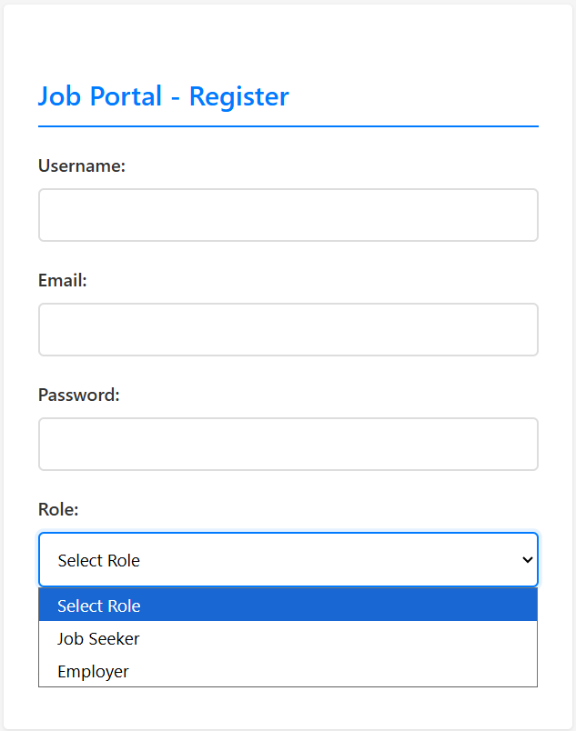
System Interface

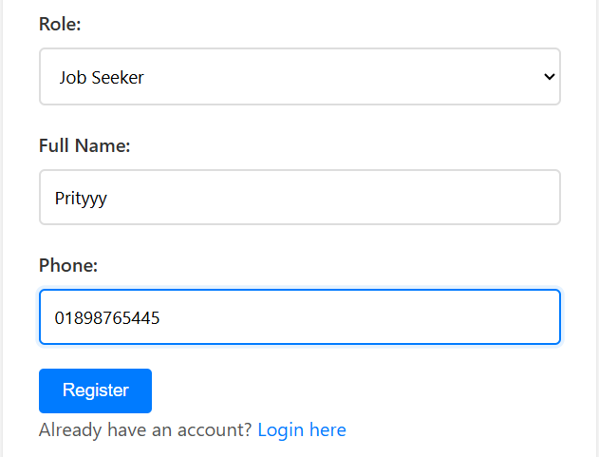

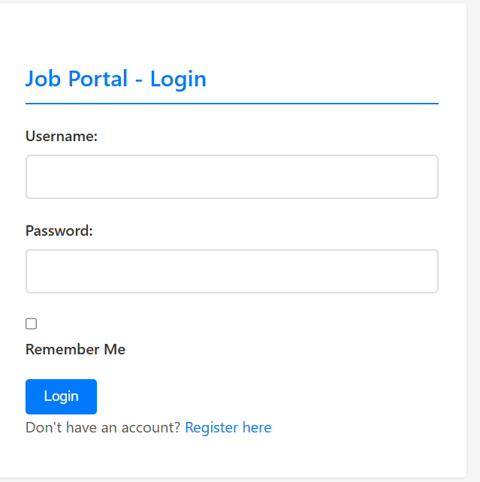

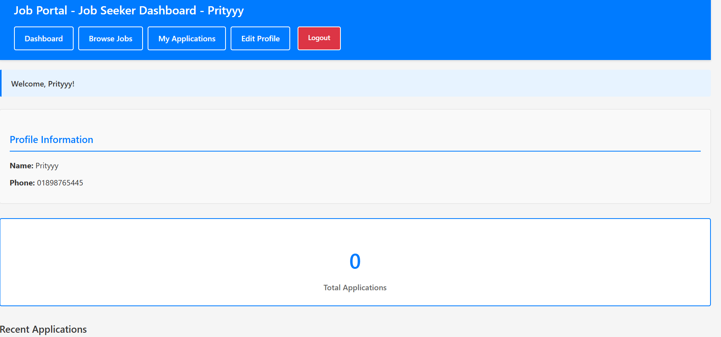

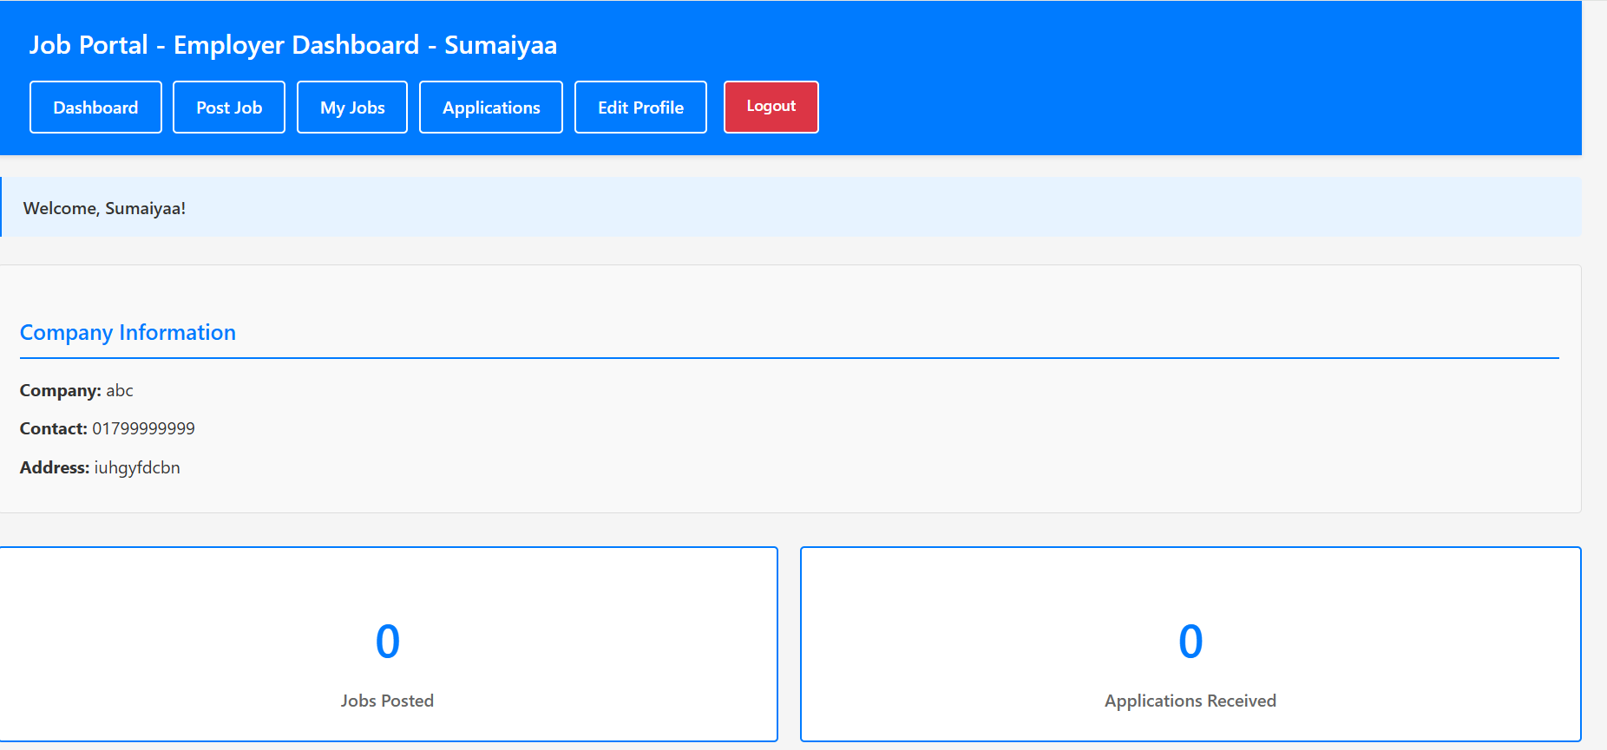
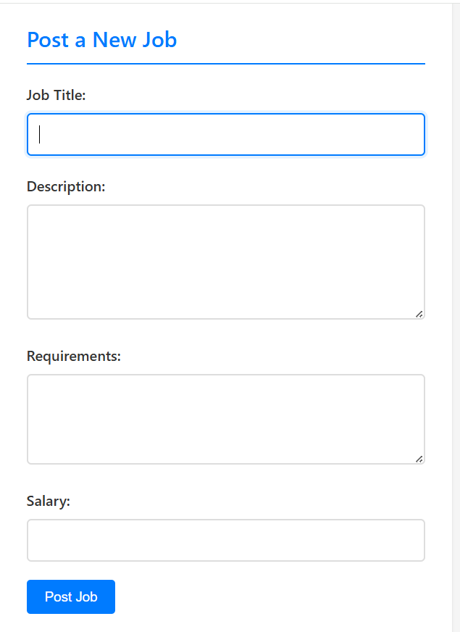

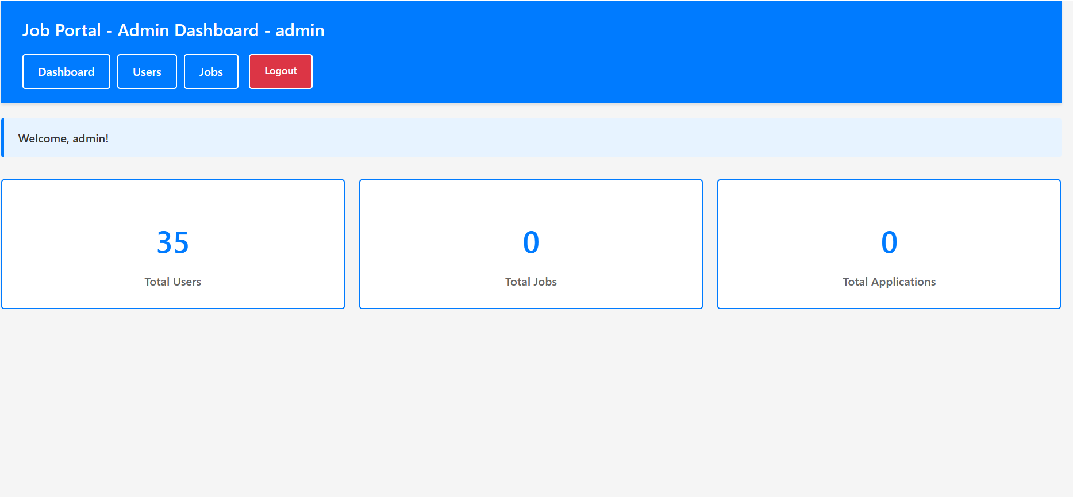

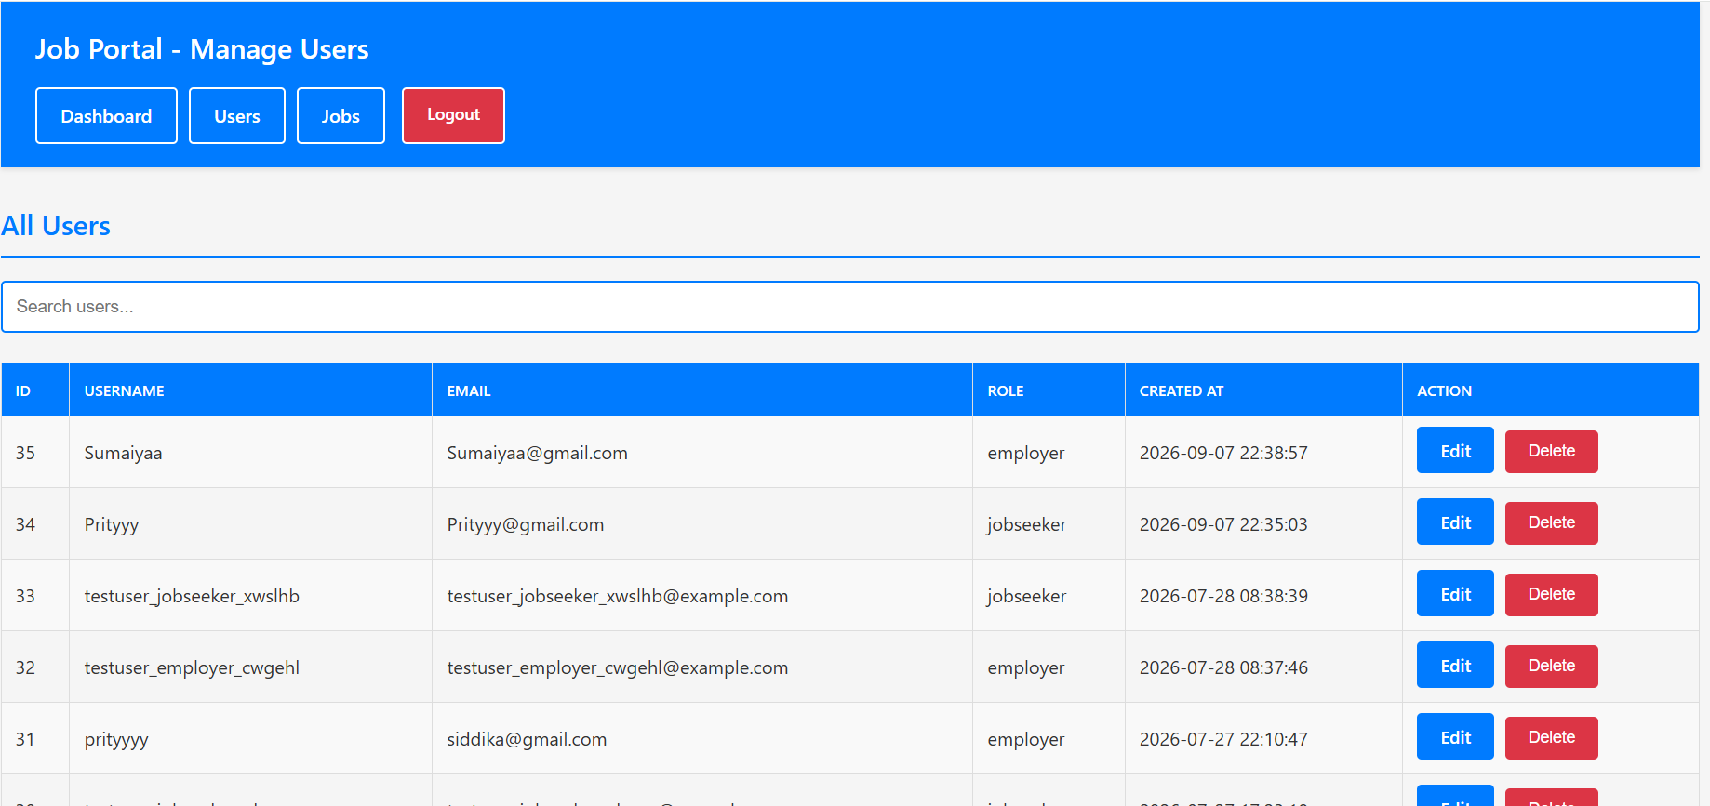

Project Requirements

Time Estimation: Total Development Time 6 Months (approx. 22 Weeks)
Start Date: 01-Mar-26 & End Date: 30-Aug-26
COCOMO Model Estimation:
Project Parameters:
➢ Software Project Type: Organic (small team, familiar web technology stack& QA)
Coefficient (Effort Factor): 2.4
Project Complexity: 1.05
Time Exponent: 0.38
SLOC: 6500 (Source Lines of Code)
Standard Working Schedule: Adjusted to 10 hours/day (high intensity)
➢ Effort Calculation:
PM=(Coefficient) *(SLOC/1000)^P = 2.4*(6500/1000)^1.05= 17.11==17person
DM= 2.50*(PM)^T= 2.50*(17)^0.38 = 7.355 months
Adjusted DM= 7.355*(8h/10h)= 5.844 months == 6months
➢ Team size Calculation:
ST= PM/DM = 17/6 = 2.833== 3 people

Cost Estimation
Personnel Costs (Based on Bangladesh Market Rates):
Role | Quantity | Monthly Rate (BDT) | Months | Total Cost (BDT)
Project  Manager/QA  lead | 1 | 80,000 | 6 | 480,000
Frontend Devs | 2 | 50,000 | 6 | 300,000
Backend Devs | 2 | 55,000 | 6 | 330,000
QA Engineers | 4 | 35,000 | 6 | 210,000
Subtotal |  |  |  | 1,320,000

Infrastructure & Tools:
Item | Cost (BDT) | Duration | Total Cost(BDT)
Cloud Hosting & Database  (DigitalOcean / Linode /  Hostinger) | 2,000/month | 6months | 12,000
Domain (.com.bd or .com) & SSL Certificate | 4,500 | One-time | 4500
Development Tools & Software (VS Code, XAMPP, Git, Postman etc.) | 15,00 | One-time | 9,000
Basic Security & Backup Tools (Cloudflare Free/Pro + Automated DB Backup) | 1,500/month | 6 months | 9,000
Email Service (for future notification – SendGrid / Mailgun) | 1,000/month | 6 months | 6,000
SMS Gateway (if OTP login added later) | 2,000/month | 6 months | 12,000
Subtotal |  |  | 52,500

Total Estimated Cost:

Development Cost: 1,320,000 BDT
Infrastructure Cost: 52,500 BDT
Contingency (15%): (1,320,000+52,500) * 0.15= 205,875 BDT
Total Project Cost: 1,203,200 BDT

FEATURES NOT TO BE TESTED
The following areas and functionalities will not be specifically addressed in this test plan. Any testing in these areas will be indirect or remains outside the current scope.
5.1 Email Notification System
The current source code does not implement email sending for registration confirmation, application status updates, or password recovery. Therefore, email delivery is out of scope.
5.2 File Upload (Resume / CV)
Resume or CV file upload functionality is not present in the current implementation and will not be tested.
5.3 Payment / Premium Features
There is no payment gateway or premium job posting feature. Financial transaction testing is outside scope.
5.4 Advanced Search Filters
Only basic title/company search exists. Location, salary range, experience level, and other advanced filters are not implemented.
5.5 Third-Party Authentication
Google / Facebook / LinkedIn login is not implemented and will not be tested.
5.6 Performance & Load Testing
Stress testing under high concurrent users and formal performance benchmarking are outside the academic scope of this test plan.
5.7 Mobile Native Application
The system is a responsive web application. Native Android/iOS apps are not part of the project.
5.8 Database Engine Internals
We will test SQL queries and data integrity within the application, but we will not test the internal source code or performance of the MySQL engine itself.

TESTING APPROACH

Testing Levels
Testing for the Online Job Portal will consist of Unit, Integration, System, and Acceptance testing levels.

Unit Testing: Will be performed by developers. Each model function (create User, verify Login, create Job, create Application, etc.) and controller action will be verified independently. Proof of unit testing must be provided before moving to integration.

Integration Testing: Will focus on interactions between modules – Authentication, Role-based dashboards, Job Posting, Application submission, Employer status update, Job Seeker application view.

System Testing: End-to-end testing of complete workflows for each role (Job Seeker, Employer, Admin). All functional requirements listed in Section 4.1 will be verified. Role-based access control and session management will be thoroughly tested.

Acceptance Testing: Will be performed by the project team (acting as end users) and optionally by the course instructor.
Acceptance criteria: all High priority test cases pass, no critical defects remaining, and core workflows function correctly.

Test Tools

The primary tools for this project are focused on the PHP/MySQL stack and automated browser validation. Selenium WebDriver with Python will serve as the primary automation tool for functional and regression testing of the web interface.

VS Code & Git will be used for source version configuration management. Developers will follow a standard push/pull workflow to ensure code stability before testing begins.

Manual Browser Developer Tools will be used for initial UI/UX inspection and AJAX request monitoring. Screen layouts and the "no-bootstrap" custom CSS designs will be reviewed by the team before proceeding to full-scale automation.

Meetings
The testing team follows a structured meeting schedule to ensure the quality and integrity of the Online Job Portal platform:

➢ Weekly Quality Review: The test team meets once every week to evaluate progress, track bug fix rates, and identify error trends as early as possible.

➢ QA Mentorship Sessions: During these weekly sync-ups, the QA Lead provides direct guidance to the team on how to properly complete test cases, refine testing logic, and resolve complex bugs identified during the week.

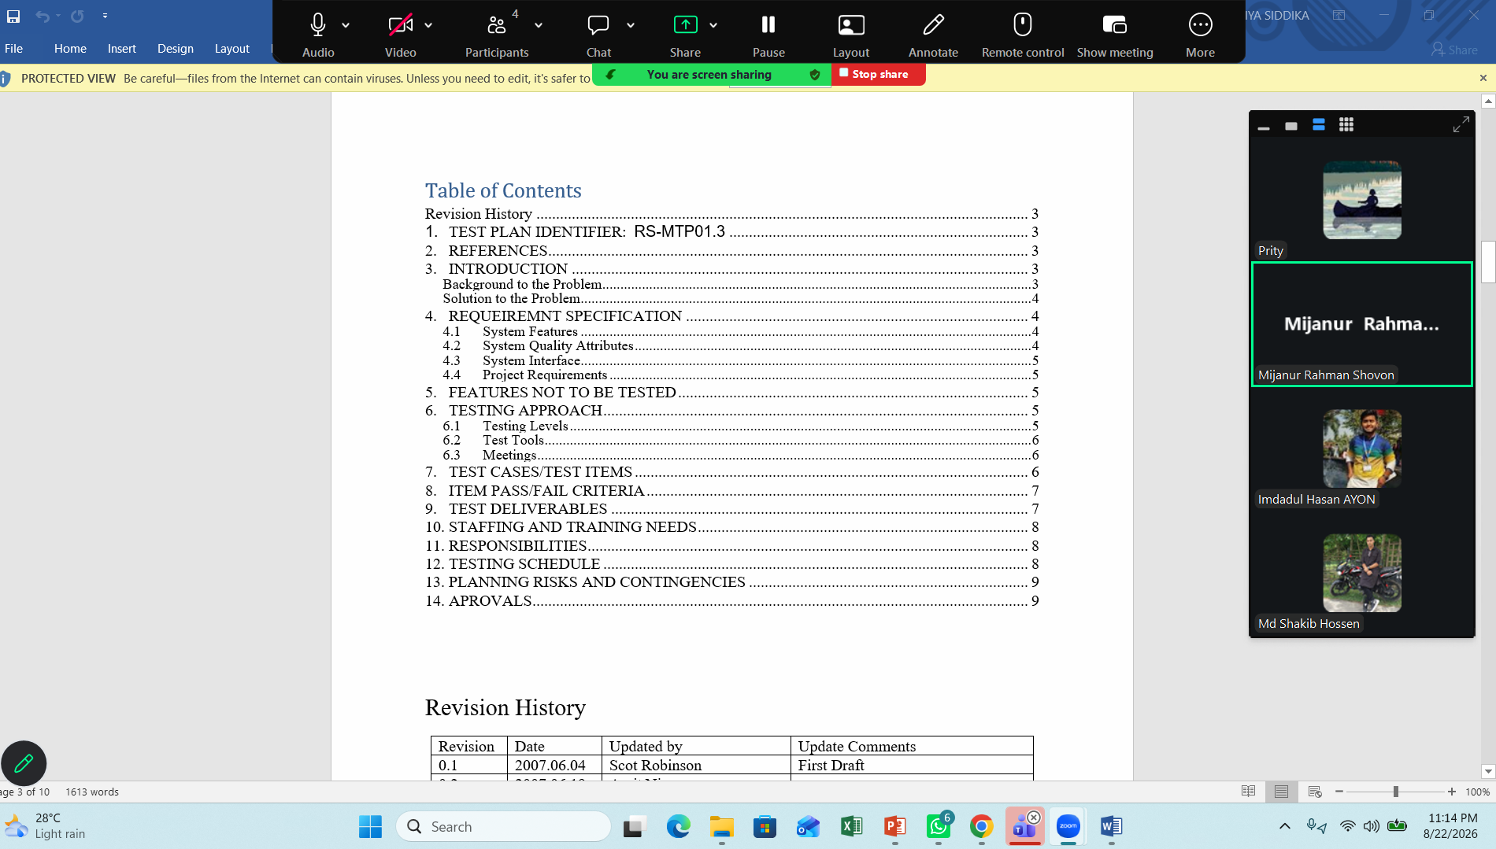
Project Meeting Session

ITEM PASS/FAIL CRITERIA
A test case is considered Passed when:
- Actual result matches the Expected result
- No unexpected errors, blank pages, or PHP/SQL exceptions occur
- Database state remains consistent with the performed action
A test case is considered Failed when:
- Actual result differs from Expected result
- System crashes, shows error messages, or produces incorrect data
- Data integrity is violated (e.g., duplicate applications allowed)
Overall System Testing Completion Criteria:
- All High priority test cases must Pass
- At least 90% of Medium priority test cases must Pass
- No Critical or Major open defects remaining
- Core end-to-end workflows (Register → Login → Post/Apply → Manage Status) function correctly for all three roles

TEST DELIVERABLES

The following deliverables will be produced as part of the testing process for the Online Job Portal. Each deliverable has a defined scope and clear pass criteria.
9.1.1 Acceptance Test Plan
Ensures the system meets business requirements, security standards, and operational expectations before final acceptance.
Scope:
➢ Job Seeker Module: Registration, secure login, job browsing/search, application submission, application tracking, and profile management.
➢ Employer Module: Job posting, editing, deletion, application viewing, status updates, and company profile management.
➢ Administrative Module: Dashboard statistics, user management (view/edit/delete), and job management (view/delete).
Acceptance Criteria:
➢ No critical vulnerabilities (e.g., SQL Injection, broken access control, session hijacking).
➢ Role-based access control correctly enforced for all three user types.
➢ Core workflows (Register → Login → Post/Apply Job → Manage Status) complete without errors.
Pass Criteria: The system is accepted when the project supervisor and team confirm that all High priority test cases have passed and pilot users experience smooth system interaction.
9.1.2 System / Integration Test Plan
Verifies smooth communication between the frontend, PHP MVC components (Controllers, Models, Views), session management, and MySQL database.
Core Testing Areas:
➢ Form data validation and correct database mapping (users, jobs, applications, profiles).
➢ Controller-to-View data rendering for dashboards and listings.
➢ Session and cookie handling (login, logout, Remember Me).
➢ Cross-module interactions (Job Seeker apply ↔ Employer view applications ↔ status update).
Pass Criteria: All modules must maintain data integrity. Role-based redirects and protected routes must function correctly without session conflicts.
9.1.3 Unit Test Plan & Turnover Documentation
Validates individual functions, security checks, and database operations before integration.
Units Tested:
➢ User registration validation (username length, password length, email uniqueness, role-specific fields).
➢ Login verification and password hashing (password_hash / password_verify).
➢ Job creation, update, and delete operations.
➢ Application creation and duplicate prevention logic.
➢ Application status update logic.
➢ Session and role management checks.
Pass Criteria: All functional units must pass tests for valid, invalid, empty, boundary, and special character inputs with zero runtime errors.
9.1.4 Screen Prototypes / UI Verification
Ensures final interfaces match the intended layouts and usability standards.
Key Interfaces:
➢ Login Page and Registration Page (with dynamic role-based fields).
➢ Job Seeker Dashboard, Browse Jobs, My Applications, Edit Profile.
➢ Employer Dashboard, Post Job, My Jobs, View Applications, Edit Profile.
➢ Admin Dashboard, Users Management, Jobs Management.
Pass Criteria: Final UI must maintain consistent navigation, readable forms, and correct role-specific menus across Chrome and Firefox.
9.1.5 Report Mock-Ups / Data Verification
Validates accuracy and presentation of system data and statistics.
Reports / Data Views Include:
➢ Admin Dashboard statistics (Total Users, Total Jobs, Total Applications).
➢ Job Seeker application history with status.
➢ Employer application list per job with status.
➢ User list and Job list under Admin panel.
Pass Criteria: All displayed counts and lists must match 100% accurate database data with correct formatting.
9.1.6 Defect / Incident Reports
Tracks, categorizes, and resolves system issues discovered during testing.
Defect Categories:
➢ P0 (Critical): Security risks, system crashes, broken access control, data loss.
➢ P1 (Major): Core feature failures (login, job post, apply, status update not working).
➢ P2 (Minor): UI issues, validation message wording, non-critical display problems.
Pass Criteria: No unresolved P0 or P1 defects may remain before final acceptance / deployment.
9.1.7 Test Logs & Turnover Reports
Maintains execution records of all tests and confirms readiness for acceptance.
Includes:
➢ Test timestamps and executed test case IDs.
➢ Module names and tester identification.
➢ QA results (PASS / FAIL) for every test case.
➢ Error logs and issue tracking references.
Pass Criteria: All planned test cases must be completed. The final set of test runs must show zero critical (P0/P1) failures.

STAFFING AND TRAINING NEEDS
STAFFING AND TRAINING NEEDS
➢ The project team consists of Three (3) members: Two (2) Developer & Testers and one (1) SQA Team Lead.
➢ Training Requirements: To provide complete and proper testing, the following training areas must be addressed:
➢ Technical Training: The developers and testers will be trained on the operations of the Native PHP MVC and AJAX real-time messaging interfaces. Before final acceptance, operations staff will be trained on MySQL database management and server communications.
➢ Administrative Training: The sales and moderation staff will require training on the new Admin Dashboards, Product Moderation screens, and User Reports.

RESPONSIBILITIES
Project  Milestone/  Activity | TM  (TestManager) | PM  (Project  Manager) | Dev Team (Developers) | Test Team  (QAEngineers) | Client  (Stakeholders)
Acceptance  Test  Documentation &  Execution | X | X |  | X | X
System/Integration  Test  Documentation & Exec. | X |  | X | X | X
Unit Test  Documentation & Execution |  |  | X | X
System Design  Reviews | X | X | X | X
Detail Design  Reviews | X | X | X | X | X
Test Procedures and Rules | X | X | X | X | X

TESTING SCHEDULE

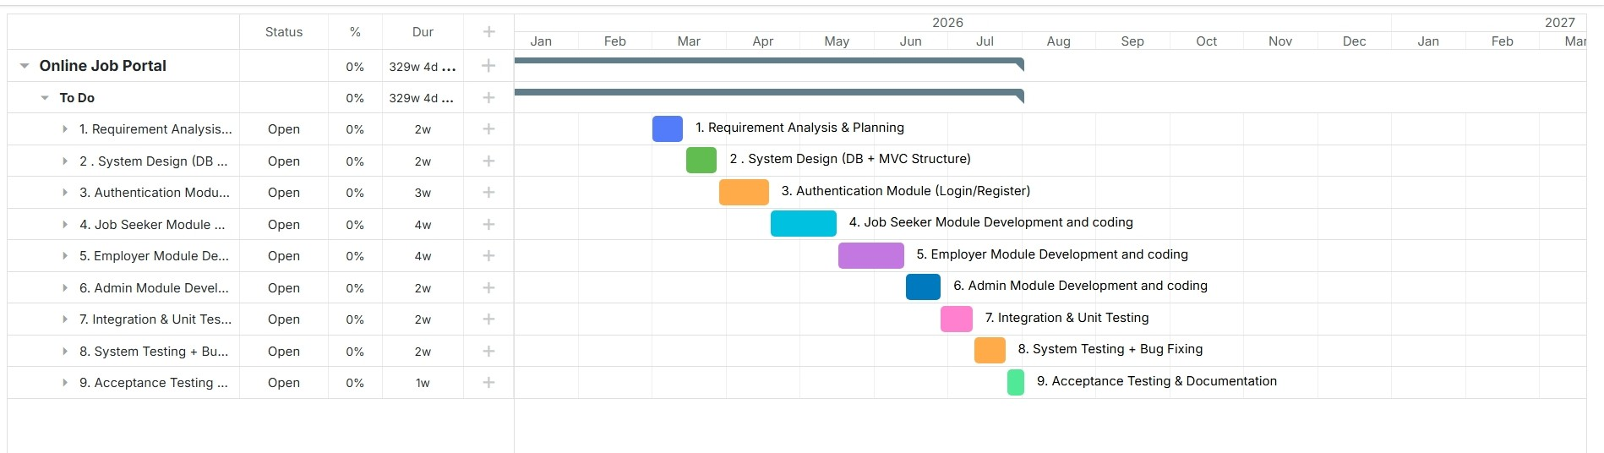

PLANNING RISKS AND CONTINGENCIES
Risk Category | Description | Impact Level | Mitigation Strategy
Requirements Risk | Incomplete, unclear, or changing functional requirements during the testing phase. | High | Freeze core requirements before system testing begins. Maintain a change log and re-evaluate affected test cases promptly.
Schedule Risk | Limited testing time due to academic deadline and overlapping course submissions. | High | Prioritize High priority test cases first. Focus on core workflows (Login, Post Job, Apply, Status Update). Conduct parallel testing where possible.
Resource Risk | Key team member becomes unavailable (illness, other commitments) during critical testing period. | Medium | Cross-train team members on test cases and environment setup. Share all test artifacts (test cases, data, results) regularly via shared drive.
Environment Risk | Local server (XAMPP), database corruption, or configuration issues block test execution. | Medium | Maintain individual local XAMPP setups for each member. Keep a clean SQL dump of test data. Document environment setup steps.
Technical Risk | Unexpected defects in authentication, session management, or role-based access control. | High | Start security and access-control testing early. Allocate extra buffer time for retesting critical modules after defect fixes.
Data Risk | Insufficient or inconsistent test data leading to incomplete scenario coverage. | Medium | Prepare a dedicated test data set in advance (Job Seeker, Employer, Admin accounts + sample jobs and applications).
Integration Risk | Issues arising from interaction between modules. | Medium | Perform thorough integration testing after unit testing. Verify end-to-end workflows for all three roles.

APROVALS
